**REvitalizeME Historic Preservation Subgrant Program**

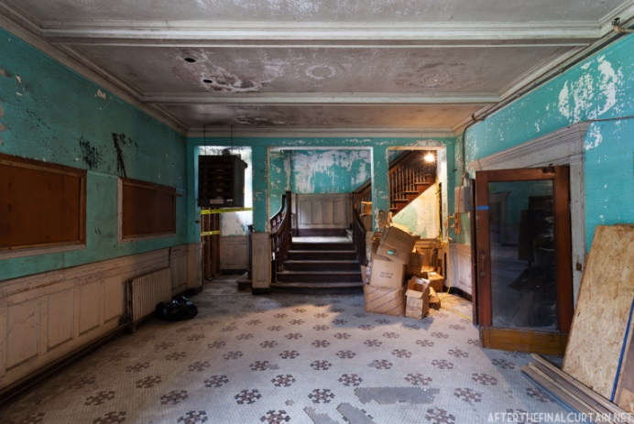

Pre-Development: to support the creation of architectural or engineering plans and specifications.

* All plans must meet the Secretary of the Interior’s Standards (SOIS);
* Plans and specifications must be developed by a licensed architect or engineer who meets the SOIS professional qualification standards.

Development: to preserve and protect the historic significance and integrity of historic properties.

* Project-specific plans and specifications that meet the Secretary of the Interior's Standards for the Treatment of Historic Properties (SOIS) must be complete at time of application and submitted with application for review.

Energy Efficiency: to support energy efficiency upgrades as a stand-alone project (minimum grant threshold of $50,000) or to be part of a larger development project.

* Applicants will be required to have a current (in the last 4 years) energy audit and to consult with MDF in preparing their application.

**Who can apply for grants?**

kdfjsdkfj

Non-profit organizations, governmental entities, educational organizations, and private property owners who own buildings or structures listed in, or are eligible to be listed in the National Register of Historic Places in the following communities:

|  |  |  |  |
| --- | --- | --- | --- |
| Augusta | Bar Harbor | Bath | Belfast |
| Biddeford | Brunswick | Bucksport | Calais |
| Camden | Caribou | Damariscotta | Dover-Foxcroft |
| Eastport | Gardiner | Gorham | Hallowell |
| Houlton | Kennebunk | Kingfield | Lisbon |
| Machias | Madawaska | Millinocket | Norway |
| Presque Isle | Rockland | Rumford | Saco |
| Sanford | Skowhegan | Stonington | Waterville |
| Westbrook |  |  |  |
|  |  |  |  |

REvitalizeME is a grant program administered by the Maine Development Foundation’s Maine Downtown Center in partnership with the Maine Historic Preservation Commission, to provide matching grants for development, pre-development and energy efficiency projects in 33 communities associated with the Center. Grant applications and manual will be made available December 1, 2019 at [www.mdf.org](http://www.mdf.org/). Applications due March 1, 2020.

**ELIGIBLE PROJECTS: Three types of projects are eligible for funding**

**How the program works (see Grant Manual for more information**

* The minimum grant award for pre-development projects (architectural plans and specifications) is $10,000 and the maximum is $50,000.
* The minimum grant award for development projects is $50,000 and the maximum is $250,000.
* Energy Efficiency grants may be included in a development proposal or a stand-alone project with a minimum $50,000.
* Approximately $640,000 is expected to be awarded as grant funding.
* This is a matching grant. Recipients will be required to raise a portion of the project cost. (See Grant Manual)
* Recipients of grant funds awarded for the physical preservation of a historic property are required to sign a Preservation Agreement with the Maine Historic Preservation Commission for a term between 15 and 20 years.
* All projects funded through this program, must meet the *Secretary of the Interior’s Standards and Guidelines for Historic Preservation and Archaeology*.
* Projects cannot use REvitalizeME grant funds AND take Federal Historic Preservation Tax credits on the same project.



**MAINE HISTORIC PRESERVATION COMMISSION**

REvitalizeME is supported through a grant from the Historic Preservation Fund, Historic Revitalization Subgrant Program, as administered by the National Park Service, Department of Interior.

**To apply properties must meet ALL of the following criteria**

**Program Contact**

**Anne Ball**

**Program Director**

**Maine Development Foundation**

**aball@mdf.org**

**207-512-4906**

* Be individually listed in the National Register, or be classified as a contributing resource within a listed district, at the National, state or local level of significance, or be eligible for listing in the National Register and have property owner consent, in writing, to list the property before the end of the project;
* Be a non-residential, non-religious building or structure (residential units as part of a mixed-use building are eligible, but not free-standing residential structures);
* Be significant under Criterion A or B in the areas of Commerce, Government/Politics, Education, Economics, Entertainment/Recreation, Health/Medicine, Industry, Performing Arts, or Social History, or, under Criterion C for Architecture, Art or Engineering;
* Be located in one of the 33 Maine Downtown Center (MDC) communities classified as a current or previous (in the last 5 years) Main Street Maine or Maine Downtown Affiliate Community that have a population of 50,000; or less as determined by the U.S. Census; and,
* Be a project that has the potential to catalyze continued investment in the historic downtown.
* The minimum grant award for pre-development proj