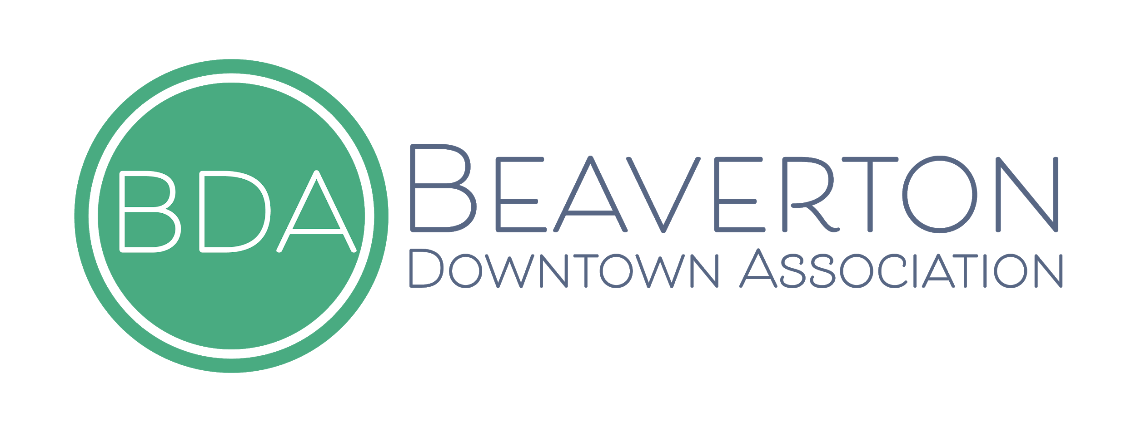
EXECUTIVE DIRECTOR INTERVIEW GUIDE

Thank you for choosing to be a part of the Executive Director interview process. We value to the insight of our community members and partners and will use your evaluation and feedback to help ensure the best possible selection. This guide is meant to provide you with the expectations, tools and resources that enable us to run a fair and consistent process for all candidates.
WHAT WE ARE LOOKING FOR:
- Driven self-starter
- Passionate about our mission and the development of the downtown community
- Clear and effective communicator
- Partnership/collaboration focused
RUN OF SHOW: 45-MINUTE INTERVIEW
Reminder: Please be present and turn off your cell phone notifications. For Zoom interviews, please also consider closing any email programs as well as instant messaging/team chat services that might distract.

- 2 MIN: Welcome the candidate and conduct introductions.
- 10 MIN: Ask the candidate to share high-level career highlights (including current role/team) as it relates to the role.
- 25 MIN: Ask functional skill and competency-based interview questions.
- 8 MIN: Candidate Q&A.

PRE-WORK
- Be prepared. Understand what we are looking for with this position.
- Review the candidates resume to have a general understanding of their background.
- Review our Interview Tips so you can create a premium and inclusive experience for each candidate.
- Be aware of any Unconscious Bias in the interview process. Unconscious biases are social stereotypes about certain groups of people that individuals form outside their own conscious awareness. Everyone holds unconscious beliefs about various social and identity groups, and these biases stem from one's tendency to organize social worlds by categorizing.
INTERVIEW TIPS:
- Communicate with care. Be on-time and present.
- Greet the applicant and engage in friendly conversation for a couple of minutes to relieve any tension.
- Tell the applicant your plans for the interview. Let them know if you'll be taking notes and that they will have an opportunity to ask questions at the end.
- Give the candidate your full attention.
- Follow the Interview Question guide.
FEEDBACK
- Please keep notes professional while focusing on skills and competencies required/asked for this position.
- Utilize the Interview Evaluation Form provided to write notes during the interview or be prepared to transfer notes verbatim over to the Interview Evaluation Form.
- Once complete, submit Interview Evaluation Form to Nicole Feightner at vicechair@downtownbeaverton.org.
- Avoid any conversation regarding candidate performance with the interview team prior to formal debrief.

ADDITIONAL NOTES:
Candidates in Round 2 have been provided links to the following to better understand the Mainstreet approach and our local organization.
Main Street America
Oregon Main Street
BDA Committee Charters
BDA Bylaws

